Surveying the financing of the Social Economy:
Demand, supply, and gaps
George Karaphillis and Stephen Moore

Defining social economy organizations
The social economy is often spoken of as filling a void; it addresses the needs and demands not met by traditional organizations in the public and private sector (Bank of England, 2003; Bouchard et al, 2006; Carleton CCI, 2006; Kay, 2005; New Brunswick, 2008; Quarter et al, 2003; Teague, 2007). The social economy developed as a response to social issues created by the mainstream economy and the limitations of the state to address inequalities through traditional avenues. Social economy organizations (SEOs) can be classified by placing them across a continuum; on one end SEOs are purely social and on the other end they are businesses with social aims. The varied nature of SEOs derives from the varied nature of the social economy. The Bank of England (2003) defines a social enterprise as “…a business with primarily social objectives whose surpluses are principally reinvested for that purpose in the business or in the community, rather than being driven by the need to maximize profit for shareholders and owners.”

Many contend that the social economy composes a substantial portion of the nation’s over all economy. Quarter et al (2003) contend that the Canadian social economy is composed of close to 200,000 non-profits that generate more than $90 billion a year and employ 1.3 million people and 10,000 cooperatives that generate more than $37 billion per year and employ approximately 150,000 people. In Atlantic Canada, there are 13,000 incorporated organizations that generate revenues of approximately $5.7 billion per year (Rowe, 2006).
External finance
Small businesses rely on accumulated profits (retained earnings) to finance their expansion; some businesses seek external financing, as in taking a bank loan, leasing equipment or selling shares. However, SEOs typically do not have significant operating profits and they rely almost exclusively on external finance for any planned expansion; they rely on grants and loans to finance their expansion. While SEOs employ millions of people in Canada and generates tens of billions in revenue, they still have troubles accessing capital. Inadequate access to capital has been identified as a serious obstacle to the growth of SEOs (Statistics Canada, 2007; Bank of England, 2003). Funding issues are exacerbated by government restructuring and a growing desire by governments to balance budgets (Scott, 2003). Furthermore, recessions take a toll on the social economy by restricting the flow of capital from lenders to borrowers and recessions also cause endowment funds to reduce their investment (Schoning). Even in good economic times, when SEOs turn to mainstream capital markets, they often face difficulties.

Stanton (2003) argues that SEOs have trouble accessing mainstream capital markets because they do not apply traditional capital market models. Bejamin et al (2004) point to another challenge faced by SEOs in traditional capital markets. They argue that a significant portion of SEOs are located in depleted or underdeveloped communities and that, “Unfortunately, low-income communities and individuals have always had limited access to financial services, affordable credit and investment capital.” Cameron (2007) echoes this concern, “Some non-profits, coops and other [SEOs] are unable to attract the equity needed to leverage conventional debt instruments.” Rubin (2008) concludes that the lack of access to capital for SEOs and community economic development (CED) organizations in depleted communities is “…a fact that greatly hampers efforts to improve conditions in these areas” (p. 1). Outside of traditional capital markets SEOs often turn to the public sector for financing. However, recent economic trends and fiscal policy has seen less money made available to SEOs. Another outcome of this is that the money that is made available to SEOs is not for core funding, but for project based funding. This pattern has raised major concerns from those in the sector (Hebb, 2006; Rowe, 2006). In the current environment, SEOs may have to address government priorities and, therefore, face having to sacrifice their goals or to drift away from their missions (Scott, 2003).

The Atlantic Canada Study
The role of financing in enabling entrepreneurial activity and economic growth has been well recognized for years. It has been recognized that financing gaps are detrimental to the creation and growth of SMEs and governments have sponsored significant research on SME financing. Although the relative size of the Social Economy is larger in Canada than in other developed countries, governments in Canada have not shown comparable interest in SEO financing issues. The Atlantic research node of the Social Economy research suite believes there is great value in gaining insights on the financing issues affecting local SEOs. This research initiative was spurred by community partners, such as the Canadian Community Investment Network and the Saint John Community Loan Fund.
There is agreement in the literature that the issues surrounding the financing of the social economy and how SEOs utilize and access external finance are central to the sustainability of the sector and organizations therein. Until now, there has been little research on the demand for and supply of capital to SEOs; most research has focused on financing options and instruments available to SEOs and the criteria used by financial institutions. Our research had two goals: focusing on Atlantic Canada, we wanted to explore the demand for external finance by SEOs and to examine the supply of external finance to SEOs.

Scope
The study used samples of social economy organizations and financial institutions within five geographical areas sufficiently restricted that we could enumerate the population of social economy organizations within it, namely Saint John NB, Cape Breton Island, Halifax Regional Municipality, Prince Edward Island, and Newfoundland. A sample was then drawn that included representatives of each organizational type of social economy organization, representatives of each sub-sector, and representatives from a variety of organizational size and age. This was followed by a survey of the majority of financial institutions and granting agencies in each community.

Methodology
The first phase of the study dealt with the demand for financing: the survey focused on samples that include representatives of each organizational type of SEO, representatives of each sub-sector, and representatives from a variety of organizational size and age. The first major task in the research project was to determine the survey sample: to develop a database of SEOs in the target areas.
Bouchard, et al (2006) have combined criteria used in defining organizations in civil society and in defining organizations in the economy and have proposed a set of four qualification criteria for SEOs: economic activity, limited distribution of surpluses to members, voluntary association with legal and decisional autonomy, and democratic governance. The multi-dimensional spectrum of organizational types is illustrated in Figure 1, with the ‘hard core” of SEOs placed in the central rectangle. For the sake of our research we decided to adopt Bouchard’s definition of the social economy.
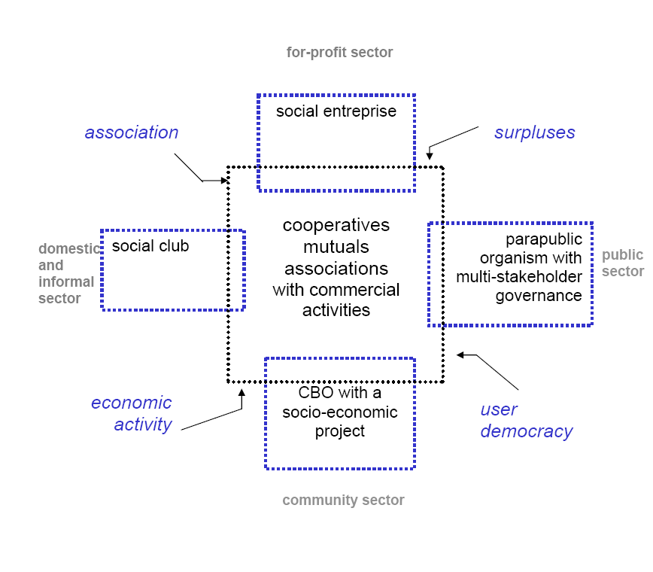
Figure 1: Characteristics of social economy organizations (Bouchard, Ferraton, and Michaud, 2006).

There was no comprehensive database of SEOs in the region and we spent a lot of time in assembling lists from different sources. Our compiled list included over 5,000 organizations. By applying the four criteria described above, this listing was reduced to 1,142 SEOs, resulting in 281 completed surveys. The surveys include self-screening questions to ensure the respondent SEOs met the four qualifying criteria. Out of 281 responses, 207 met all four SEO criteria.
The second phase of the study focused on the supply of finance and surveyed the financial institutions and granting agencies in each of the five geographical areas. We compiled a list of 224 sources of external finace in the five study areas. Surveys were completed by 56 agents and officers of financial institutions and government agencies.

Summary Profile of SEOs
The majority of SEOs surveyed are small organizations: three quarters have fewer than 20 employees, with forty six percent having fewer than 5 employees. However, six percent of SEOs employ over 50 people. One third of organizations have a budget below $100,000, but half of the SEOs have an annual operating budget over $250,000, with one third surpassing the $500,000 level.
The majority of organizations surveyed are well established: 59 percent of respondents have been established for over 20 years. SEOs mentioned sales of goods and services, grants, and donations as their primary sources of funds on an ongoing basis. The majority of SEOs (77 percent) have pursued external financing. SEOs predominantly use grants, loans, and lines of credit for financing. The primary reason for external financing cited is to expand services, purchase a building, and purchase equipment.

Financing assessment
Lending officers of banks and credit unions overwhelmingly indicated that repayment capacity, security/collateral, credit history, management experience, and quality of the business plan are the most important factors considered in assessing loan applications in general. The survey also indicated that low profitability, lack of security and personal equity, reliance on grants, low financial expertise, and incomplete business plans were often encountered in loan applications from social enterprises.
Only a quarter of bank officers indicated they could relax their lending criteria for community-owned organizations, as did 50 percent of credit union officers. However, 77 percent of CBDCs indicated they could relax the criteria for community organizations and apply preferential terms.
Only a quarter of bank officers and forty five percent of financiers in general were aware of the term ‘social economy; an even smaller minority were aware of the correct definition.
Findings summary
The study suggests there are a few gaps in financing organizations in the social economy, especially for startups. Rejection experienced for SEO financing is fairly high at 42 percent. There is heavy reliance on government grants: 60 percent of respondents had received grants in the previous 12 months and 74 percent of SEOs planning an expansion are pursuing grants to finance the expansion. Interestingly, forty percent of SEOs are pursuing public/corporate fundraising for expansion also.
The survey of financiers indicated their concern over security/collateral, personal guarantees, and lack of personal equity, in SEO financings. Mainstream SMEs face similar obstacles in securing startup financing; organizations in the social economy, with their multiple bottom-line mandate and additional organizational impediments, face a much bigger challenge. More than 60 percent of the financiers stated that typically SEOs’ low collateral, profitability, and revenue are very problematic.
Reliance on donations and government grants and contracts also make SEO startups risky prospects for debt financing by mainstream lenders. More than 30 percent of financiers stated that SEOs’ heavy reliance on grants and government contracts was problematic; 24 percent of SEOs mentioned they were unsuccessful in obtaining financing because financial institutions “...do not finance social enterprises”.
A large percentage of the Atlantic SEOs surveyed (42 percent) plan to expand or start a new venture. They are reporting that they require large amounts of financing: a quarter of the growing SEOs require funds in excess of $500,000 for expansion. It is understood that projects in the housing, real estate, healthcare, green energy, and hospitality sector are capital intensive and require large size investments; however, less than 13 percent of SEOs have raised this level in the previous 12 months, indicating a funding shortfall is likely.

References
Bank of England. (2003). The Financing of Social Enterprises: A Special Report by the Bank of England. Bank of England, Domestic Finance Division. Bank of England.
Benjamin, L., Rubin, J. S., & Zielenbach, S. (2004). Community Development Financial Institutions: Current Issues and Future Prospects. Journal of Urban Affairs , 26 (2), 177-195.

Bouchard, M. J., Ferraton, C., & Michaud, V. (2006). Database on social economy organizations: The qualification criteria. Chaire de recherche du Canada en economie sociale, Research Series No R-2006-03, Universite du Quebec a Montreal

Cameron, S. (2007). Community Investing in Canada. Canadian Community Investment Network Cooperative.

Mook, L., Richmond, B. J., & Quarter, J. (2005, January). Centre for Urban & Community Studies: Research Bulletins. Retrieved April 30, 2009, from Social Accounting for Social Economy Organizations: http://www.urbancentre.utoronto.ca/researchbulletin.html

Quarter, J., Mook, L., & R. B. (2003, March). Retrieved April 30, 2009, from What is the Social Economy?: http://www.urbancentre.utoronto.ca/researchbulletin.html

Rubin, J. S. (2008). Adaption or Extinction? Community Development Loan Funds at a Crossroads. Journal of Urban Affairs , 30 (2), 191-220.

Saint John Community Loan Fund. (2009). Welcome. Retrieved April 30, 2009, from Saint John Community Loan Fund: www.loanfund.ca

Schoning, M. Global Trends in Financing the Social Sector: How Successful Social Entrepreneurs Mobilize Resources and Leverage their Ideas. Schwab Foundation for Social Entrepreneurship.

SME FDI (2006), Key Small Business Financing Statistics, SME Financing Data Initiative, Government of Canada, Ottawa

Statistics Canada. (2007). The Daily. Retrieved December 3, 2008, from Survey on Financing of Co-operatives: http://www.statcan.gc.ca/daily-quotidien/081203/dq081203d-eng.htm

